Overall: We need to revise the layout because it’s currently too similar to PolishedPD. The client does not want this site to resemble PolishedPD in structure, flow, or visual presentation. The content itself is fine, but the layout and overall design approach must be reworked so it feels original and not like a copy‑and‑paste version. Please adjust the layout, spacing, component structure, and visual hierarchy to create a distinct presentation.

Home Page
Phone is 804 601 0469
Slogan - “Where health smiles grow” should be the words typed. 

Logo needs a white background to be able to be seen since the video is darker in color
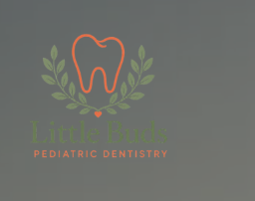

Meet The Dentist:
Update Vidisha’s picture in Meet Dr. Patel with the picture we emailed.
Update the verbiage below:
Dr. Vidisha Patel founded Little Buds Pediatric Dentistry to give children in Midlothian and throughout Chesterfield County a place where they can feel comfortable and confident at the dentist. With compassion and patience at the heart of every visit, she's dedicated to helping your child build healthy habits and a positive relationship with dental care that lasts a lifetime.

Remove banner throughout the website-

Our Little Buds Principles
Remove banner- 

Want this design to be changed below and create a different layout with the new content that I have listed. ***Instead of the boxes, I want the wreath (leaves) from the logo incorporated somehow

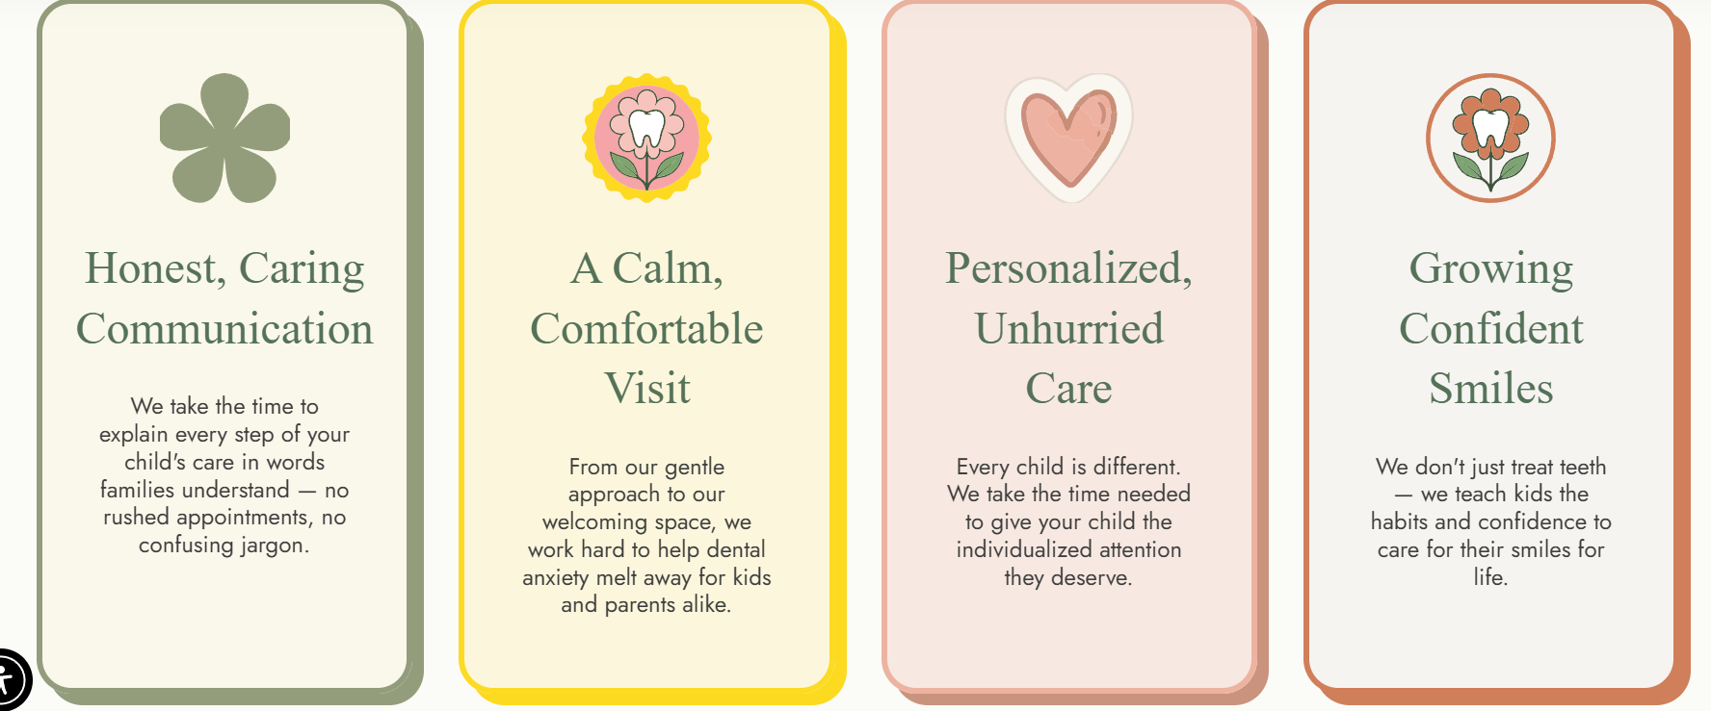

⭐ Patient‑First Philosophy
We make dental visits easy and stress‑free for families. Our patient‑first approach includes flexible hours including Saturday appointments, responsive communication, and a welcoming atmosphere that supports every child’s comfort. Your schedule, your needs, and your child’s well‑being always come first.

⭐ Modern Pediatric Dental Care
We use advanced tools and techniques to give growing smiles the safest, gentlest care possible. With innovative technology and specialized treatment options, our high‑quality pediatric dentistry delivers precise results and a smooth experience for kids of all ages. We also offer minimally‑invasive options to keep treatment comfortable and stress‑free.

⭐ Expertise With Heart
Our team blends specialized training with genuine compassion. With a board‑certified pediatric dentist, kid‑friendly technology, and a supportive staff, we deliver specialized pediatric care that meets children where they are — including those with unique needs.

⭐ Child-Centered Comfort
Our space is designed to help kids feel calm and comfortable. Soothing colors, playful details, a sensory nook, and ceiling TVs make visits relaxed and engaging. With child‑centered comfort, we meet kids where they are and celebrate their progress.

Hours (update Monday - 8:30 to 5, Tuesday By appt only, Wednes - closed, Thurs - 8:30 - 5, Friday 8:30 - 1:30, Saturday- appt only) :
